
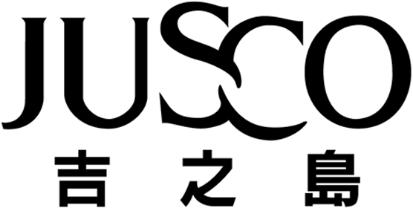
JUSCO STORES (HONG KONG) CO., LIMITED
吉之島(香港)百貨有限公司
(Incorporated in Hong Kong with limited liability)

ANNOUNCEMENT

The Board of Directors (the "Board") of Jusco Stores (Hong Kong) Co., Limited (the "Company") announces that Mr. Kozo Murata has been appointed an Executive Director and the Deputy Managing Director of the Company with effect from 20th June, 2002.

The Directors would like to welcome Mr. Kozo Murata to the Board.

By Order of the Board

Kazumasa Ishii

Managing Director

Hong Kong, 20th June, 2002

Please also refer to the publish version of this announcement in the The Standard.

